Pot Holder/Oven Mitt Festival - 2023

Help us celebrate this beautiful and functional kitchen essential in the St. Arnaud Pot Holder/Oven Mitt Festival.
This event will run as part of the 2023 CWA State Creative Arts Exhibition, but is open to everyone!
CWA members, family, friends and the general public are invited to show your skills in creating a stunning, but practical Pair of Pot Holders and/or Pair of Oven Mitts
All Pot Holders/Oven Mitts must be entered in one of the following sections. You may enter up to two per section, marked as A or B on the entry form.
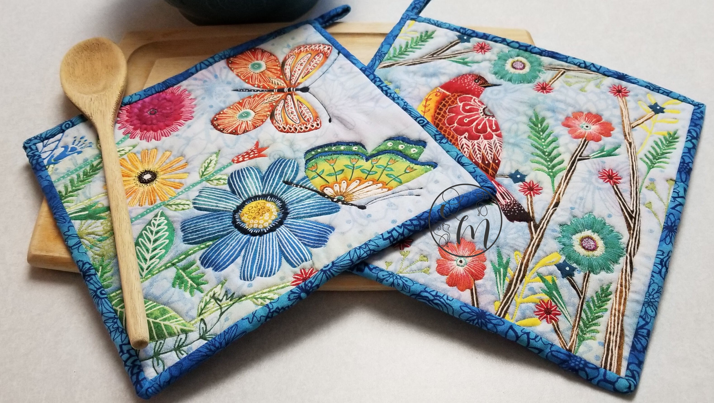
Sections:
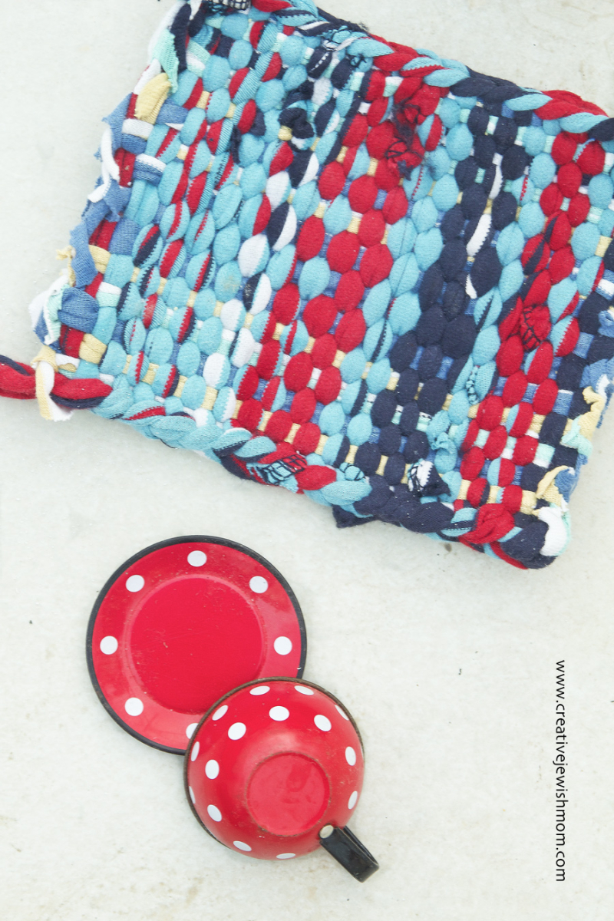
Pair Pot Holders
267. Patchwork
268. Sewn
269. Quirky
270. Embroidered
271. Knitted
272. Crocheted

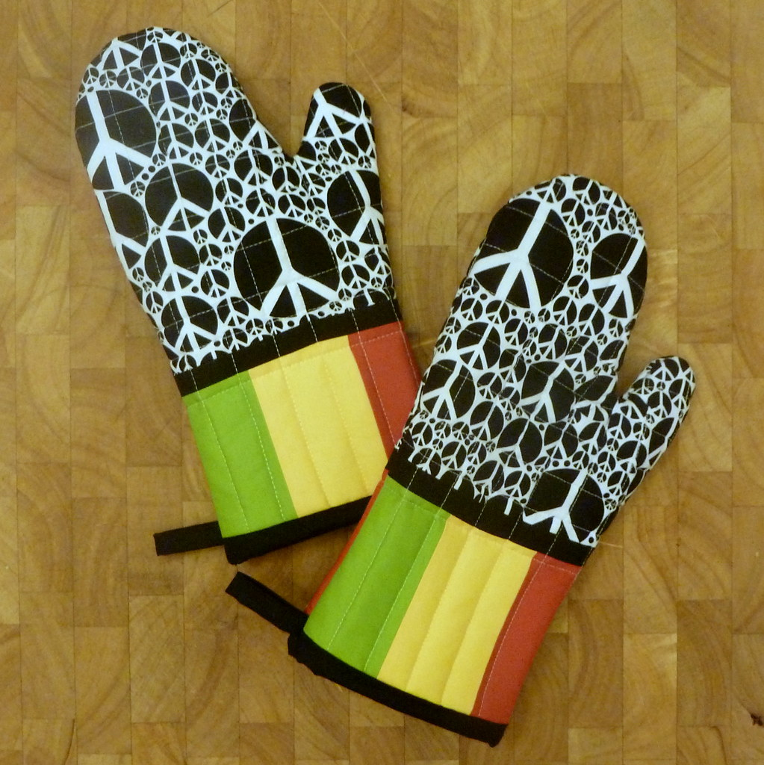

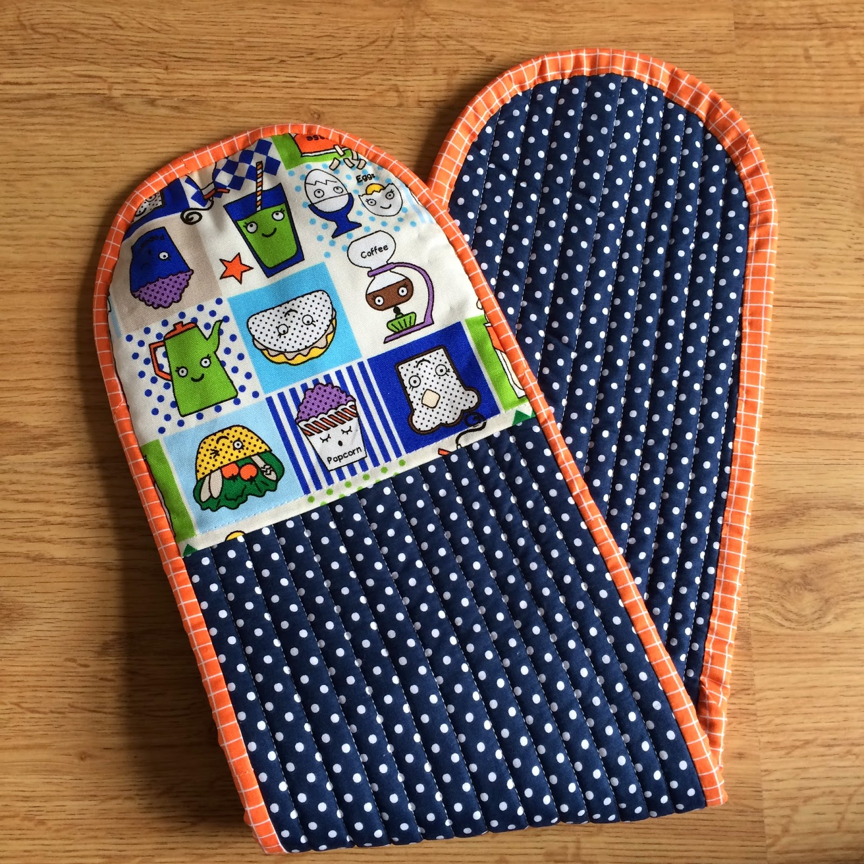
Pair Oven Mitts

273. Patchwork
274. Sewn
275. Quirky
276. Embroidered

Prizes

Prizes and First, Second and Third Prize Certificates may be awarded for the following categories:

- Adult CWA of Victoria members
- Junior CWA of Victoria members under 18 years of age
- Other adult entrants
- Other entrants under 18 years of age
How to participate:

- Create: You may enter into as many sections as you wish, including two Pair of Pot Holders or Oven Mitts per section, not identical to each other.
The items must be made by the entrant within the past two years and not used.

- Enter: Complete the entry form and send by email or post, remember to complete all contact details on the entry form, including all sections you are entering, with a description of the item. Closing date for entries is 30 June 2023.

Your entry tickets will be returned to you by email or mail. Please print out the copy of your entry form as it has your entry number and pickup time in top right-hand corner. You will also need to printout, trim and attach your entry tickets to the back of your item/s.

- Post/Deliver: Post your items with the white copy of entry form to
CWA of Vic Inc., 3 Lansell Rd., Toorak Vic 3142 to arrive no later than 18 July 2023 or deliver your entries to St. Arnaud Town Hall, St. Arnaud on Monday 24 July between 2.00pm and 4.00 pm

- Entry Fee: $5.00 per person
The entry fee is payable by cash if you are hand delivering your entries to either Toorak or St. Arnaud.
If you are mailing your entries to Toorak, phone CWA of Vic Inc. on 9827 8971 to pay by credit card, quoting your entry number as reference.

- Visit: Bring your family and friends to see the Pot Holder/Oven Mitt Festival and visit the Creative Arts State Exhibition, in the St. Arnaud Town Hall, Friday 28 July 9.00am – 5.00pm and Saturday 29 July 9.00am – 3.00pm.
Admission is $12.00 per adult, children are free
.
- Pick Up: your items at the end of the Exhibition from St. Arnaud Town Hall on Saturday 29 July between 3.15pm and 4.30 pm, a designated time slot is on your entry form, please bring this form with you.
Disclaimer: The Creative Arts Committee of the Country Women’s Association of Victoria Inc. reserves the right of final judgement in showing any article and in all matters connected with the Pot Holder/Oven Mitt Festival, including all care, but does not take responsibility for the loss of or damage to any entries. The Committee also reserves the right to photograph and publish photographs of articles entered in the Pot Holder/Oven Mitt Festival
Or pick up from 3 Lansell Rd., Toorak on Wednesday 2 August between 11am and 3pm.
Or include a stamped, self-addressed post pack for return of your items.
Entries without return packaging which are not picked up will be donated to those in need.

